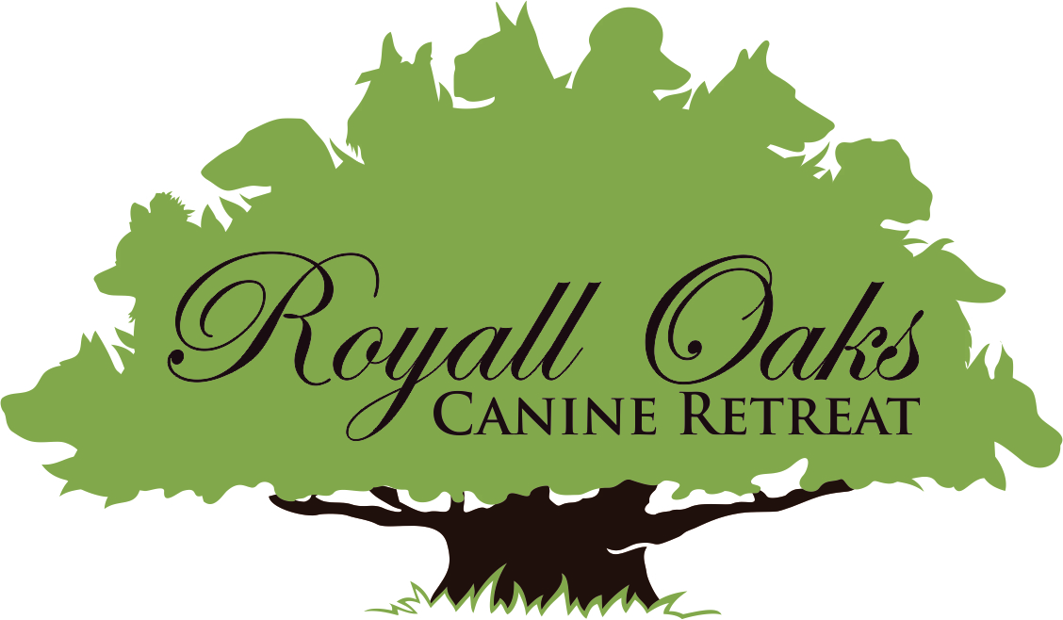

Client & Dog Information

Owner Name: _______________________________________________________

Address: ___________________________________________________________
City: ____________________________________________ Zip: ______________

Email: _____________________________________________________________

Cell Phone: __________________________

Home Phone: ________________________

Work Phone: _________________________

Veterinarian: ________________________________________________________

Address: ___________________________________________________________

Phone: _____________________________

Emergency Contact Information

1st Name & #: _______________________________________________________

2nd Name & #: ______________________________________________________

Is there anyone else who may be authorized to pick up your pet? Yes ___ No ___

If yes, please list name & # _____________________________________________

Name Dog #1: _______________________ Breed: ________________________

Color/Markings: _____________________________________ Age: ___________

Male ______ Neutered ______ Female ______ Spayed ______

Name Dog #2: _______________________ Breed: ________________________

Color/Markings: _____________________________________ Age: ___________

Male ______ Neutered ______ Female ______ Spayed ______

Name Dog #3: _______________________ Breed: ________________________

Color/Markings: _____________________________________ Age: ___________

Male ______ Neutered ______ Female ______ Spayed ______

If you have more than one dog may they be fed together? _____________________

Is your dog housebroken? ______________________________________________

Type & Brand of food provided @ home. _________________________________

Amount _____________________ Frequency _____________________________

Is your dog allowed to have treats? _______________________________________

Does your dog have any allergies, medical/health problems? If yes, please explain.

__________________________________________________________________

__________________________________________________________________

* Has your dog ever shown aggression or bitten anyone? If yes, please explain.

__________________________________________________________________

__________________________________________________________________

Does your dog… (check all that apply)

Jump/Climb Fence: ______ Run Away _____ Bark Excessively _____ Dig _______

Show Food Aggression ______________ Show Toy Aggression ________________

People Aggression ______________ Adult? _____________ Child?_____________

Charge through Open Doors/Gate_________ Chew / Destroy Property _________

Will your dog come when called? __________

What is your dog’s energy level?

Dog #1 Active______ Passive______

Dog #2 Active ______ Passive______

Dog #3 Active ______ Passive______

Please list below any special instructions or any information you would like for us to know about your dog.

__________________________________________________________________

__________________________________________________________________

__________________________________________________________________

__________________________________________________________________

__________________________________________________________________

__________________________________________________________________

How did you hear about us? (Example: Friend, Facebook, Craigslist, Community Impact, Woodlands Online, etc.)

__________________________________________________________________

Boarding Contract

This is a contract between Royall Oaks Canine Retreat (herein after called “kennel”) and the pet owner whose signature appears below (herein after called “owner”).

1. By signing this contract and leaving his/her dog with the kennel, owner certifies to the accuracy of all information given about said pet.

2. Owner acknowledges that it is not possible to protect against all risks to their dog at any time, even with the exercise of due care and attention and whether at the kennel or in transport, that these risks include injury, escape, theft, disease and fire.

3. Owner specifically represents to kennel that the dog has not been exposed to rabies or distemper within a thirty day period prior to boarding and that it is in good health and current with all required immunizations.

4. As we strive to be a flea-free facility, if upon admission your dog is found to be carrying fleas, we will administer flea treatment and a $10.00 charge/pet will be billed to the owner.

5. If dog becomes ill or if the state of the dog’s health requires professional attention, the kennel in its sole discretion, may engage the services of a veterinarian and/or administer medicine or a special diet or give other requisite attention to the dog and the expenses will be paid by the owner. In the case of a medical emergency, the maximum dollar amount that the owner authorizes to be spent on veterinary care is:

$_____________. (Please fill in dollar amount or unlimited.) If dog dies while boarding at the kennel the body will be stored at either the owner’s veterinarian or as per owner’s instructions.

6. I understand that, by giving consent below, my dog(s) will be with other dogs during its stay at the kennel. I understand that the kennel will not admit dogs into play areas that are obviously aggressive. If, however, a dog acts out of character or unpredictably and my dog is injured I agree to not hold the kennel or their staff liable in any way for these unforeseen acts. If injury occurs I authorize kennel staff to obtain medical/surgical treatment for the safety and comfort of my dog and that I will reimburse the kennel for all costs incurred for this treatment. Also, if for any reason my pet is found to be incompatible with the group play, the kennel has the authorization to separate my dog into a private kennel for the duration of its stay.

7. I release the kennel from all liability for injury, damage or loss suffered by me, my dog(s), members of my family or guests and which loss is or may have been caused directly or indirectly by an act or omission of the kennel or by any person or property in the vicinity and during the course of the kennel providing the services requested and whether resulting from negligence or any cause. I agree to indemnify the kennel and save it harmless from all claims and costs of any nature and kind in respect of any loss caused or contributed to by my dog(s) including any damage to the property of the kennel and I assume the sole risk of and the responsibility for same.

8. Any controversy or claim arising out of or relating to this contract, or the breach thereof, or as the result of any claim controversy involving the alleged negligence by any party to this contract, shall be settled in accordance with the rules of the American Arbitration Association and judgment upon the award rendered by an arbitrator may be entered in any court having jurisdiction thereof. The arbitrator shall, as part of his award, determine an award to the prevailing party of the costs of such arbitration and reasonable attorney fees.

9. This contract contains the entire agreement between the parties. All terms and conditions shall be binding on the heirs, administrators, personal representatives and assigns of the owner and kennel for this visit and all subsequent visits.

Owner Signature: _____________________________________________ Date: _____________

Media Agreement
(Please circle one & initial)

____________I DO / DO NOT give my permission for my dog’s photo to be taken and
Initials posted on Royall Oaks Canine Retreat’s website, Facebook Page and/or for other media purposes.

Release of Medical Information/Vaccination Records
(Please circle one & initial)

____________I DO / DO NOT give my permission for my dog’s medical information
Initials and/or vaccination records to be released by my veterinarian to Royall Oaks Canine Retreat.

Socialization Agreement
(Please circle one & initial)

____________I DO / DO NOT give permission for my dog(s) to socialize with other dogs.
Initials

Notes or Instructions - Special Needs/Geriatric Guests/Other:

__________________________________________________________________

__________________________________________________________________

__________________________________________________________________

__________________________________________________________________

__________________________________________________________________

__________________________________________________________________

__________________________________________________________________

__________________________________________________________________

__________________________________________________________________

__________________________________________________________________

__________________________________________________________________

__________________________________________________________________

__________________________________________________________________

__________________________________________________________________

__________________________________________________________________

__________________________________________________________________

__________________________________________________________________

__________________________________________________________________

__________________________________________________________________

__________________________________________________________________

